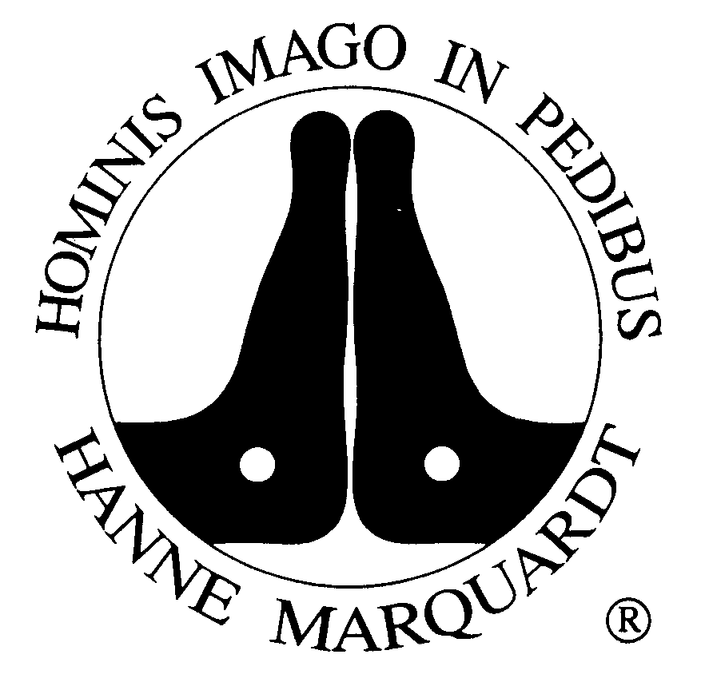
Reflexology therapy on the foot

The History
People have known for thousands of years of the relationship between the feet and inner parts of the body, and of the possibility of carrying out treatment on the feet. At the beginning of this century this practical knowledge was systemized and brought into a modern context. First by an American Dr. William Fitzgerald, later by the masseuse Eunice Ingham and last by the nurse and masseuse Hanne Marquardt, around 1967. Over many of years this method was further developed and adapted to meet the needs of people with present day illnesses.

The Method
The reflex zone therapy of the feet is a manual discipline, which has become a precisely defined form of natural treatment over years. All the organs and systems of the human body are «reflected» on the foot on a smaller scale. A healthy foot is free of pain, feels warm, is flexible and has a good circulation. The gentle «pain» that can be triggered in some places on the foot by the treatment of reflexology serves as a kind of «signpost», giving information on where the affected person needs support, where the therapy can be started and built up. Reflexology can be used as treatment on its own or also in combination with other methods.

Indications and Effects
Foot Reflexology is an order and regulation therapy. It promotes the self-healing powers of humans, and can be used at any age. It can be used as wellness treatment and/or as health prophylaxis.
Through this therapeutic treatment, improvements can be achieved of all complaints in the organic, bony, muscular body as well as in the emotional state of the human being.

- Acute and chronic pain in the spine, joints and muscles
- Headaches and migraines
- Diseases of the digestive organs and urinary tract
- Diseases of the respiratory tract, with increased susceptibility to infections and allergies
- Complaints related to menstruation and menopause
- Complaints of mother and child during pregnancy and after birth
- Fatigue, restlessness, nervousness, sleep disorders, difficult life situations

Patients with acute and chronic inflammation of the veins or the lymphatic system, with an aneurysma, with a transplant or with high fever should not be treated with foot reflexology. In psychoses its important to ask first the doctor.

Patients notice certain reactions during the intervals of the treatment. They are welcome and expected reactions of the body to the given impulse, even if they are perceived as temporarily uncomfortable. They are not to be considered as new complaints. After a few treatments positives changes in individuals complaints can be observed.

Course of Treatment
Since not everybody reacts equally quickly to a given stimulus, it is important to set a treatment series of six to ten sessions. At the beginning I will perform a short anamnesis. You may formulate where you wish to have the emphasis of the treatment. The treatment begins with a palpation of both feet. In the 48h following you are encouraged to observe how your body reacts. Your feedback helps me to custom-tailor your therapy.
The treatment takes between 45 minutes. After that you need a rest of 10 minutes, so the set stimuli can fade away. If possible, the initial treatment sessions should be planned in weekly intervals.

Should you have any questions or insecurities, please contact me. I thank you very much for your trust and am looking forward seeing you.

